**How to add EKS cluster creds.json file to Panorama**

Step 1: Switch to SharedServices Account

<https://d-9f6701bb71.awsapps.com/start/#/>

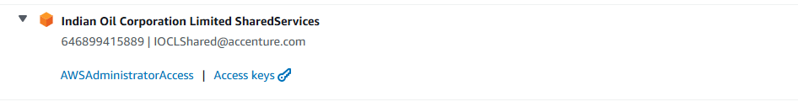

Step 2: Navigate to EC2 Instances in Mumbai region

Windows Bastion Server: i-0a1cc3283ed210633 (INMUABSWP002)

Step 3: Connect to EC2 instance via RDP client. Use the key pair for authentication.

Step 4: Once logged in to the Bastion server, use below link for Panorama Account : <https://iras-panorama.iocliras.in>

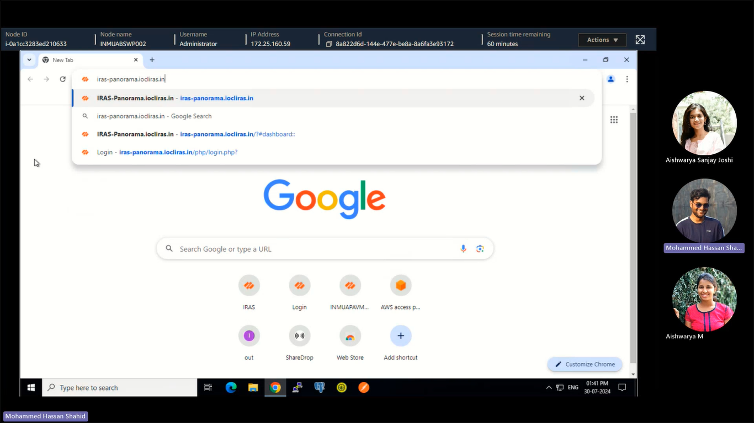

Step 5: CN and VM series firewalls can be checked under Panorama tab >> Managed Devices >> summary.

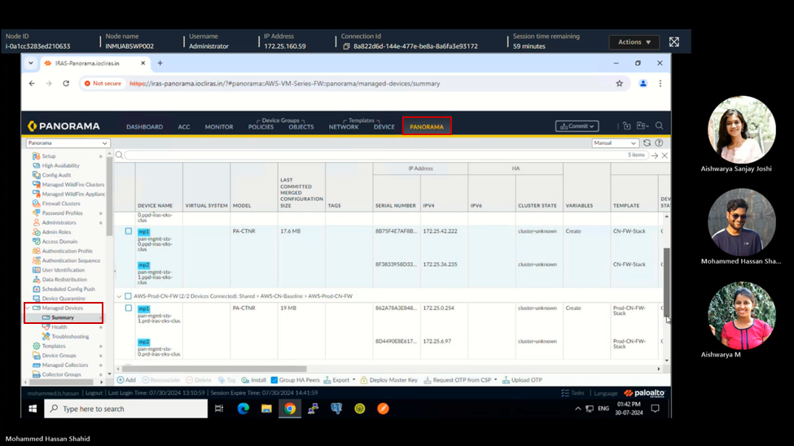

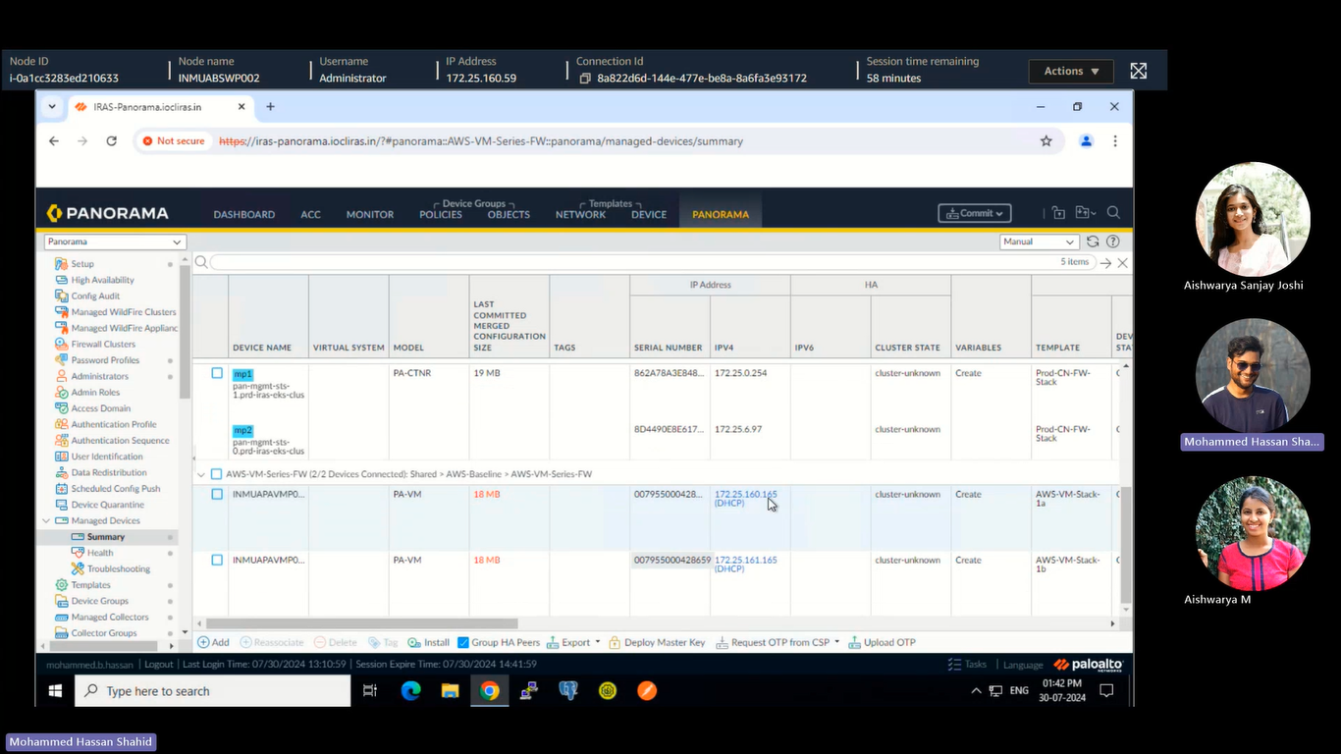

Step 6: To add a cluster, Add cluster configurations such as name, API server address, Type, Credentials JSON file. Once added all the required attributes, Validate the attributes by clicking Validate and Click Ok.



